# [Chris Meloni carries Mariska Hargitay on his back in Emmys pic that is making fans swoon](https://www.today.com/popculture/tv/chris-meloni-carries-mariska-hargitay-back-emmys-photo-rcna47787?cid=sm_npd_td_tw_ma)

Meloni will always have Hargitay’s back — and this photo proves it.

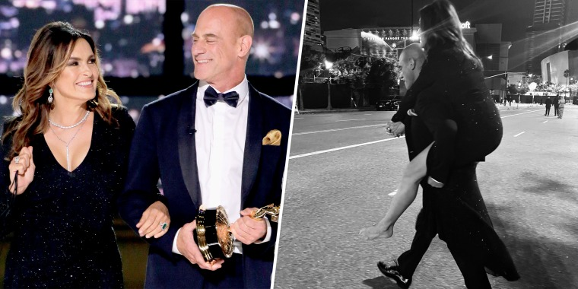

Partners carrying partners.Getty Images / @chris_meloni via Twitter

Sept. 14, 2022, 7:06 PM -03

By [Liz Calvario](https://www.today.com/author/liz-calvario-tdpn248724)

Whether it’s the streets of New York or Los Angeles, Chris Meloni has Mariska Hargitay’s back!

The former “[Law & Order: SVU](https://www.today.com/popculture/tv/law-order-brings-3-casts-together-first-time-historic-crossover-rcna44435)” co-stars treated their fans to a reunion at the [2022 Emmy Awards](https://www.today.com/popculture/awards/emmys-winners-list-2022-rcna47376) on Monday, Sept. 12, glamorously [posing on the red carpet](https://www.today.com/popculture/awards/mariska-hargitay-chris-meloni-tease-svu-fans-nod-characters-tension-em-rcna47422) for photos and teasing fans with [an almost-kiss on stage](https://www.today.com/popculture/awards/mariska-hargitay-chris-meloni-tease-svu-fans-nod-characters-tension-em-rcna47422) while presenting.

Meloni kept the Emmys moments going two days later when he shared a photo from after the show, which included him giving Hargitay a piggyback ride after she was a “high heel casualty.”

“How it started. How it ended,” the actor [tweeted](https://twitter.com/Chris_Meloni/status/1570138537005322240) alongside two black-and-white photos of the two. He also added the hashtags #Eleganceissurprisinglylight #partnerscarryingpartners #highheelcasualty.

Hargitay had also shared a shout-out to her glam team on [Instagram](https://www.instagram.com/p/Cif5O5KJ8YF/?hl=en), as well as posted a photo of her and Meloni departing the event.

"Night night," she captioned her [Instagram](https://www.instagram.com/p/CicBklwOXGq/?hl=en) post.

The night was extra special as they attended the awards ceremony together 12 years after their last appearance. In 2010, the actors presented the award for outstanding writing for a drama series, with Hargitay nominated for best leading actress in a drama series.

Making their comeback, the "Law & Order: SVU" star wore a black Christian Siriano gown, while the "Law & Order: Organized Crime" lead opted for a navy tuxedo.

Later in the telecast, the actors were part of a pre-taped presenting skit where they chased a thief carrying an Emmy. They then appeared on stage, catching the perpetrator and handed him over to authorities.

After making a joke about how she has two Emmys, Meloni said, “Well, Mariska, we did it.”

“Again,” they both said in unison, before [leaning in for an almost kiss](https://www.today.com/popculture/awards/mariska-hargitay-chris-meloni-tease-svu-fans-nod-characters-tension-em-rcna47422) and quickly turning away to present the nominees for lead actor in a comedy series.

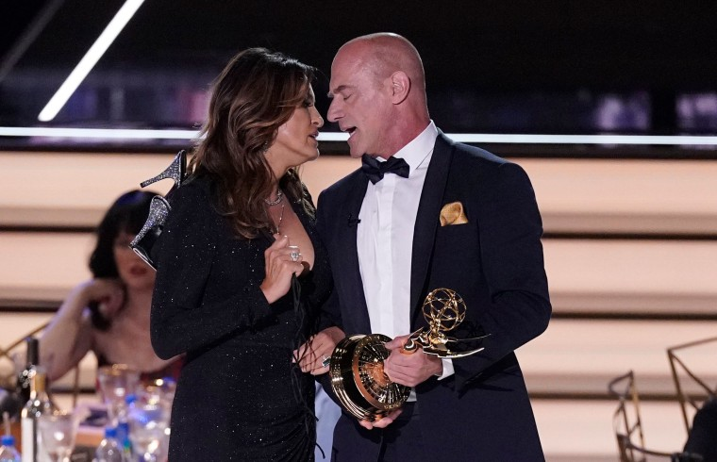Mariska Hargitay, left, and Christopher Meloni pretend to kiss at the 74th Primetime Emmy Awards on Monday, Sept. 12, 2022, at the Microsoft Theater in Los Angeles.Mark Terrill / AP

The moment was one that fans have been wanting for [the actor's characters,](https://www.today.com/popculture/tv/olivia-benson-elliot-stabler-relationship-timeline-law-and-order-svu-rcna37289) Olivia Benson and Elliot Stabler.

The dynamic duo will be seen on the small screen again when “Law & Order,” “SVU” and “Organized Crime” share a [three-way crossover](https://www.today.com/popculture/tv/law-order-brings-3-casts-together-first-time-historic-crossover-rcna44435) on Sept. 21.